Home page
Remove Portfolio
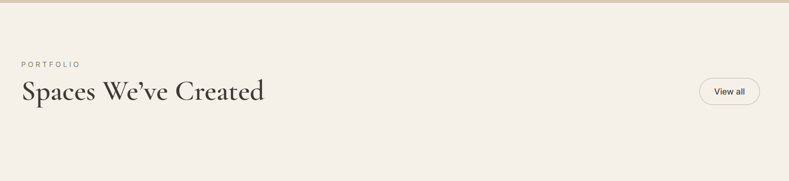
Add Backsplash tab (green)
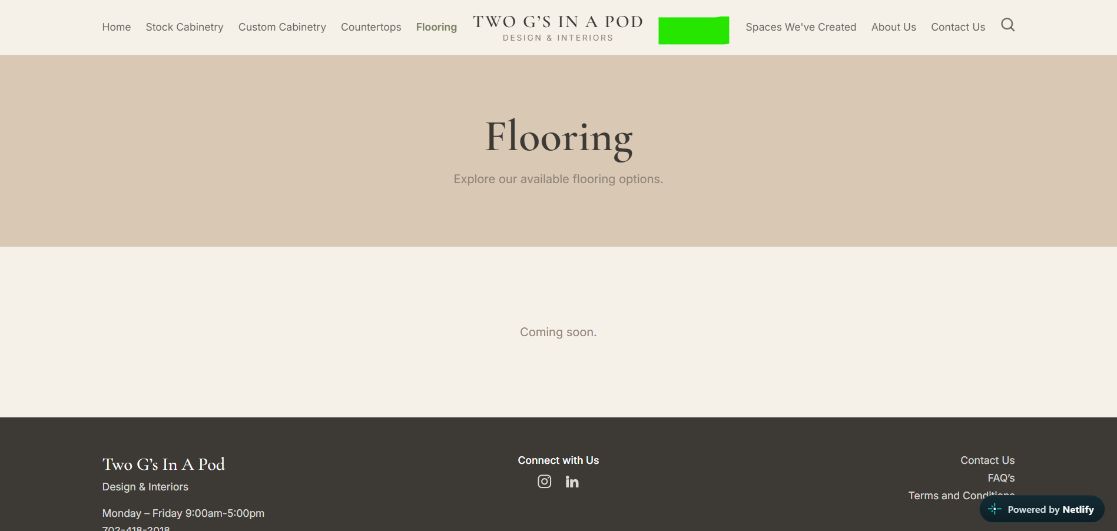

Add scroll bar of tiles for
Countertops
Flooring
Backsplash
I would like to have access to files that are on scroll bars so I can change them or reorder them

Can we change each tab to display a different color?
Theme colors for Headline (orange check mark area to have color change)
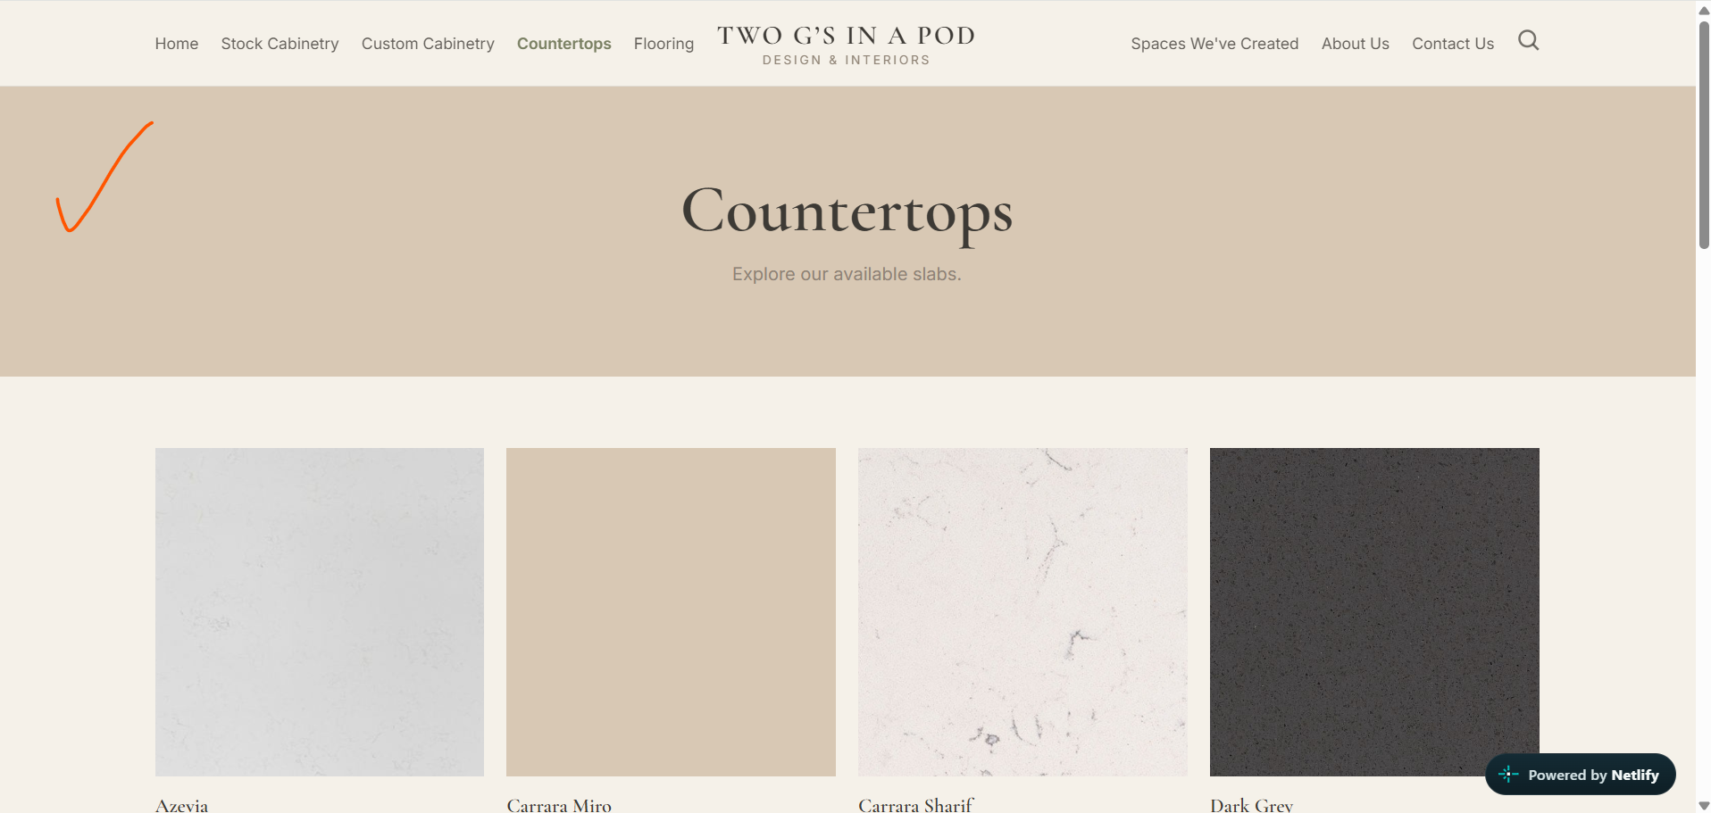
Home Page – Warm Sand
Stock Cabinetry – Light Taupe
Custom Cabinetry – Warm Greige
Countertops – Muted Olive
Flooring – Deep Olive
Backsplash – Dusty Blue
Spaces We’ve Created – Soft Sage
About Us – Warm Greige
Contact Us – Mushroom Taupe
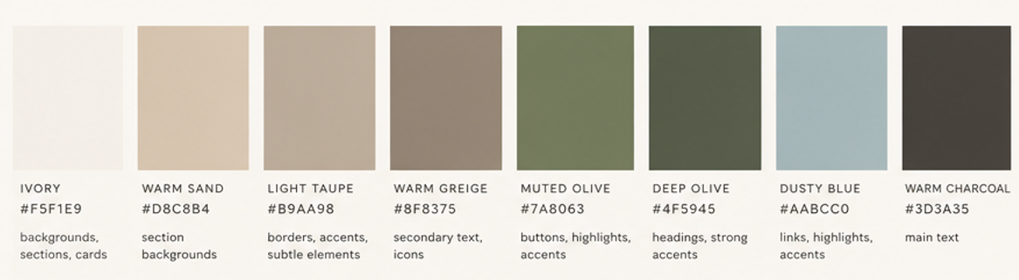
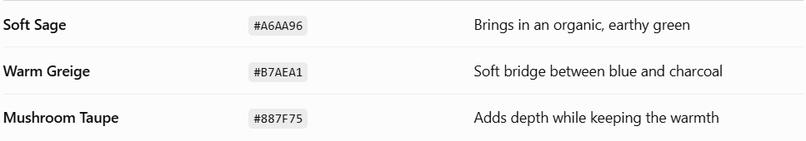

Stock Cabinetry
Standard sizes and colors available
Add: All tab
When you click on door tile
Left Center
Name Door Tile Photo
Specs *can we make a small scroll gallery where I would have access to switch the photos
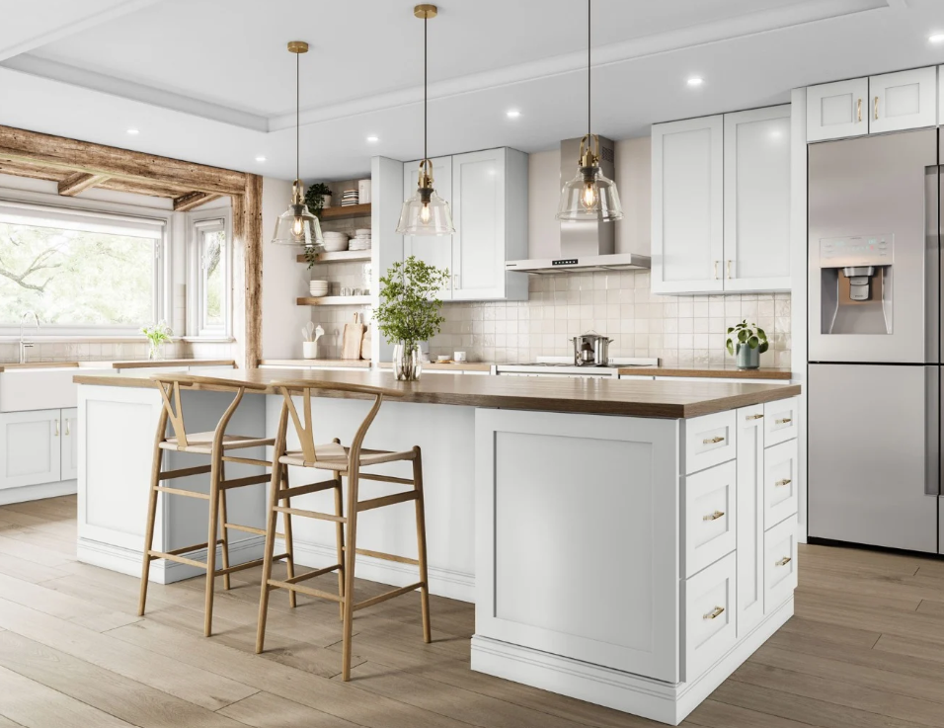
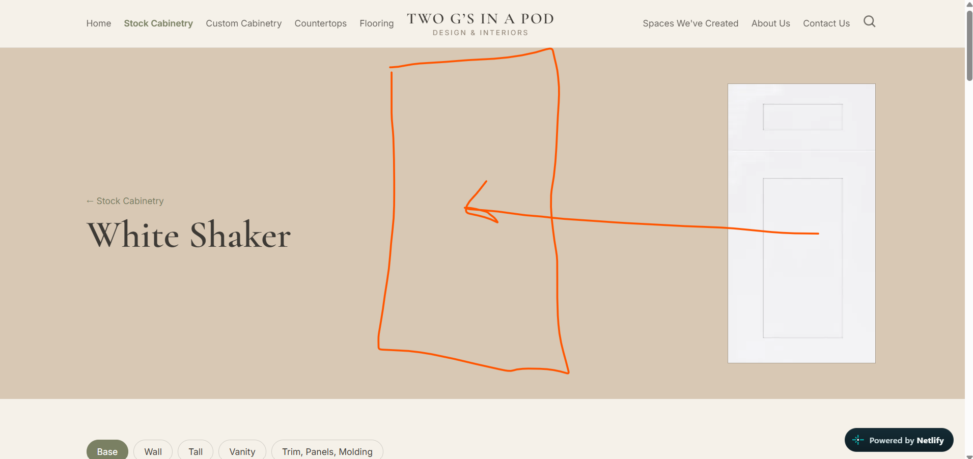

Custom Cabinetry
Tabs
Door Profiles Great!
Paints Remove all, remove textured melamine
Stains Great
Textured Melamine add

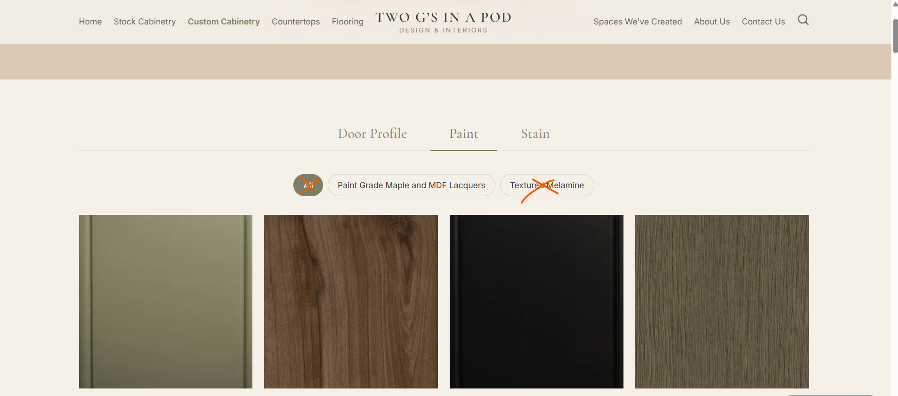

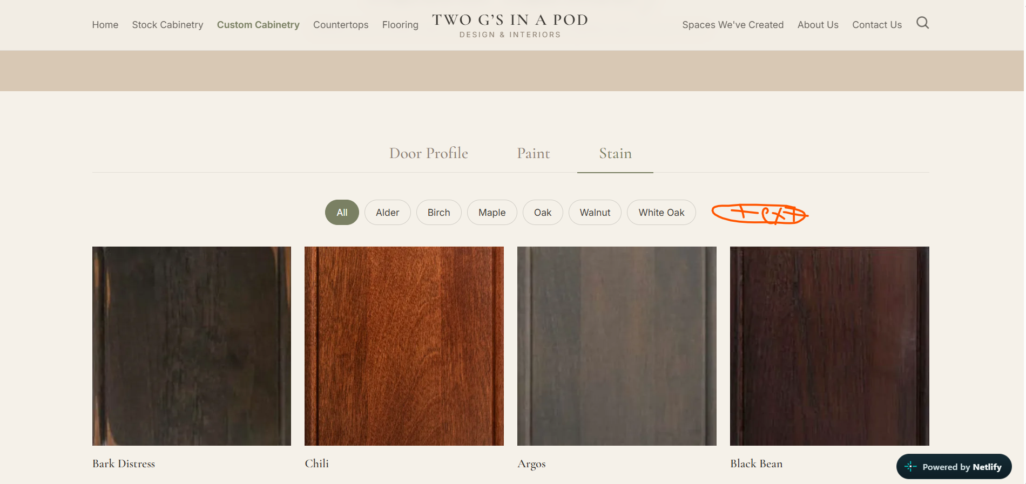
Countertops
Discover thoughtfully selected surfaces designed for both everyday living and exceptional style.
Tabs
Granite Quartz Natural Stone Porcelain Solid Surface

When you click on the tile, I would like it to redirect to a page that has
Large photo of slab centered (rectangle in shape more like a slab would be)

Below Name
About this stone (I did add to description in admin panel)
Specs (added to admin panel)
Example:
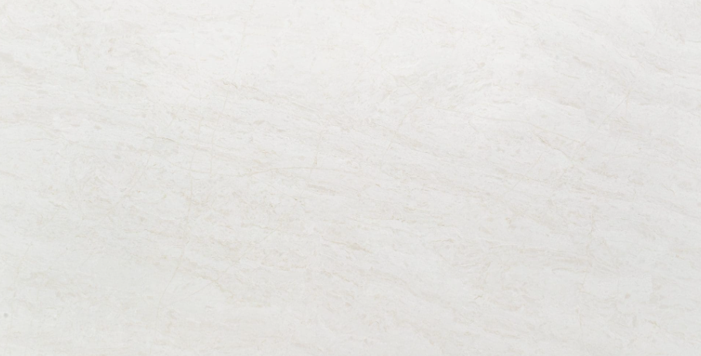
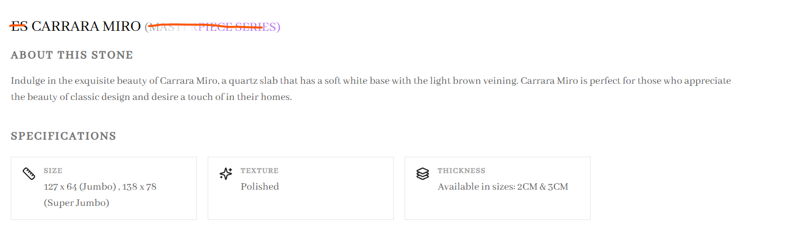
Flooring
Explore flooring selections that bring warmth, character, and cohesion to your space.
Tabs
Engineered Wood Laminated Wood Solid Hardwood Resilient Vinyl Tile

Square tile, when you click on tile redirect to another page that has

Left
Photos to scroll
Right
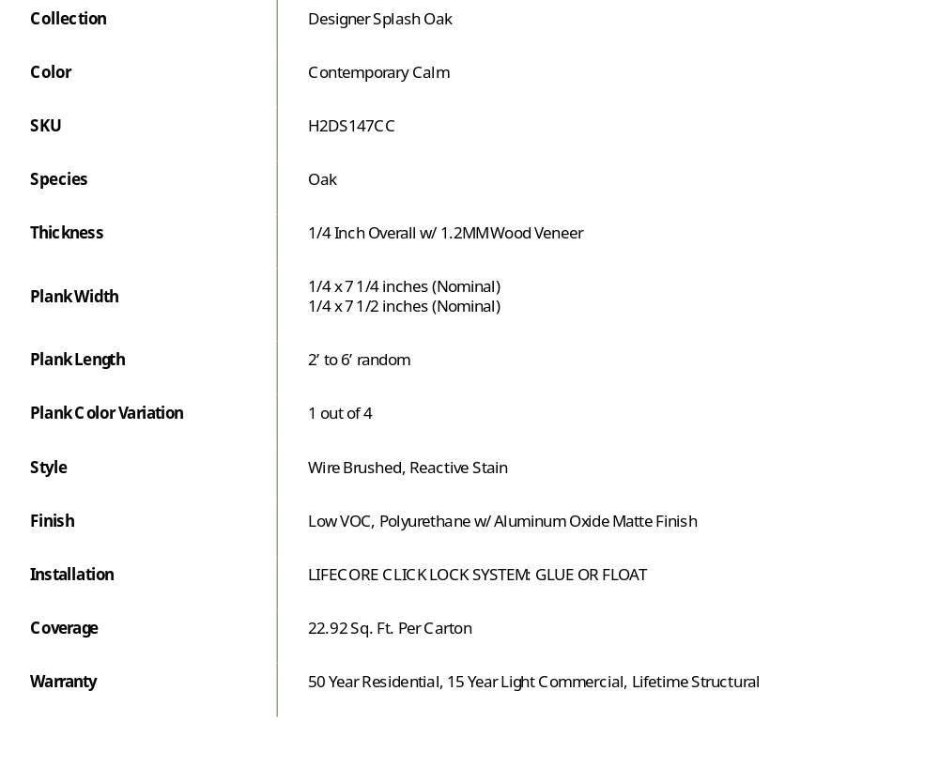

Example:
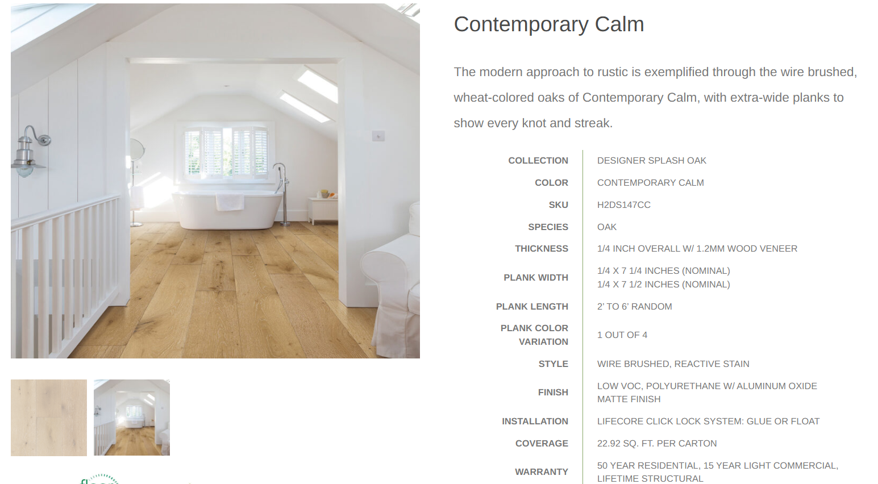

Backsplash
Refined details, beautiful textures, and timeless finishes that complete the space.
Tabs
Subway Mosaic Marble 3D Decorative Handmade

Spaces We’ve Created
Explore our completed projects, where thoughtful design, carefully selected materials, and beautiful craftsmanship come together to create spaces that feel like home.

Terms & Conditions
Does not populate on website
Does populate on mobile verison
Bold
- Our Services
- Design Information & Client Responsibilities
- Etc

Bottom Right
Contact Us
FAQ’s
Measurement Guide
Shipping & Delivery Information
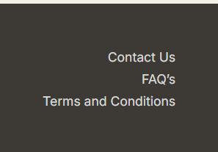

Bottom Left
Two G’s In A Pod
Design & Interiors
Monday - Friday
9:00am - 5:00pm
Also by appointment
702-418-2018
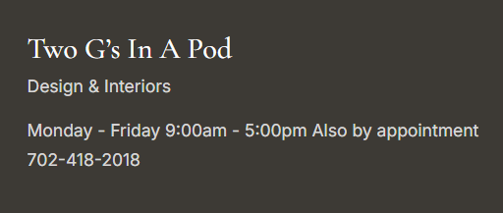

Mobile Version
Left Center Right
Hamburger Two G’s In A Pod search icon
Design & Interiors
Hamburger
Home
Stock Cabinetry
Custom Cabinetry
Countertops
Flooring
Backsplash
Spaces We’ve Created
Measurement Guide
Shipment & Delivery Information
About Us
Contact Us

Is it possible for auto scroll like the website or does it have to me manual like it is currently?

Admin Panel

Stock Door Style
Drag to reorder

Stock All
tabs
drag to reorder within tabs

Door Profiles
Paints
Stains
Textured Melamine
Drag to reorder

Countertops
Tabs
Drag to reorder within tabs

Floor
Tabs
Drag to reorder within tabs

Backsplash
Tabs
Drag to reorder within tabs

I would like to have access to change, headlines, item name, description, specs, etc

Measurement Guide
I want to be able to have a downloadable PDF measurement guide that customers can download to print

Site Content
Can I add or remove categories?

